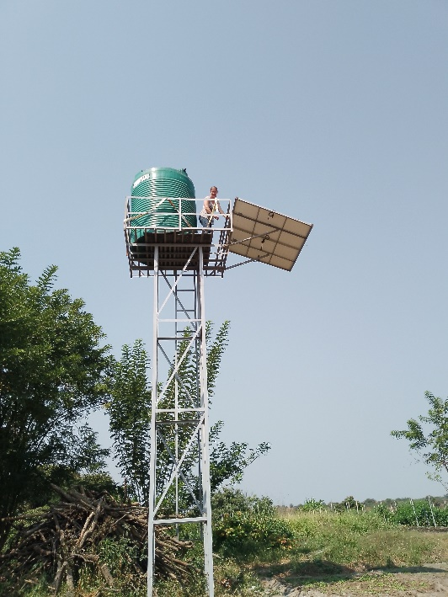

Dear Friends, October 2024

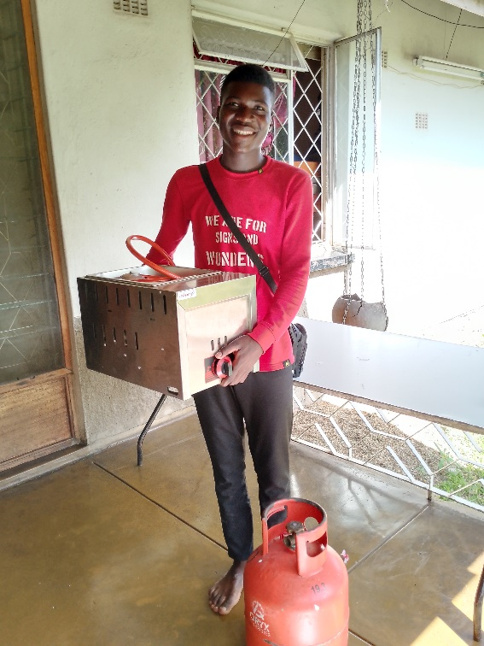The past year has been a very successful one in the ministry and life of Living Hope, peppered with inevitable challenges. We have an enormous amount to be thankful to God for. A few highlights are below:

43 students have graduated with various tertiary qualifications – some of them have jobs in their field of study, some we’re helping to empower to make a livelihood until they gain employment. We are now focusing on practical skills training like carpentry, mechanics, agriculture and tailoring so that upcoming students can make a living without relying on employers.

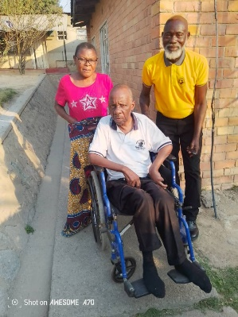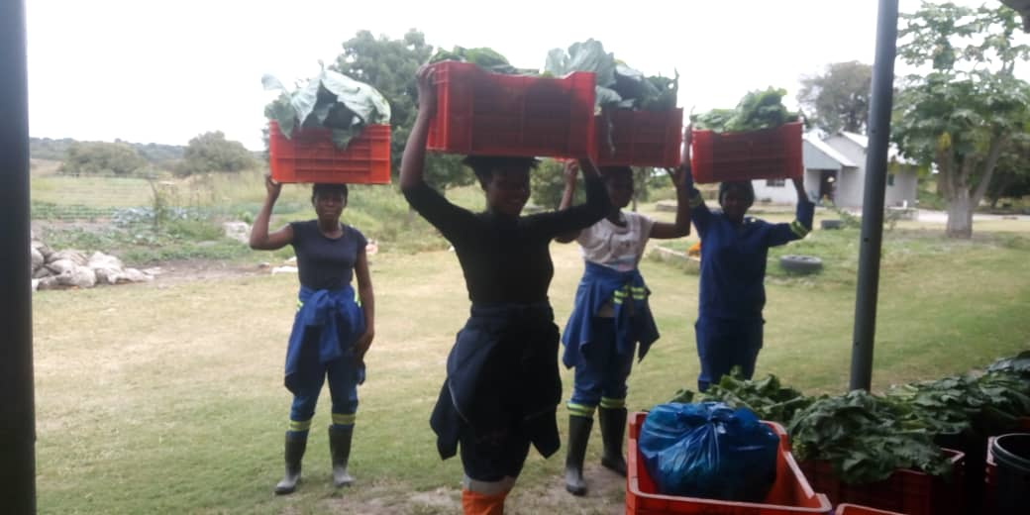Our distributions of clothing and other items have continued, with a focus on reminding the most in need that God has heard their prayers, seen their tears, and has not abandoned them. It has been a wonderful opportunity to refresh people’s faith in Jesus and to encourage them in their struggles.

The farm is now continuously hosting trainees on attachments from some of our local training Colleges. We get to teach them Farming God’s Way and to share daily devotions with them.

We were blessed with the gift of a borehole on the farm – the timing of which has been impeccable – Zambia is suffering a severe drought and yet the farm is producing more produce in a drought than it has ever produced before. Our new Management team have stepped up and risen to a mighty task.

That same borehole has kept our home and the Transit Home and Office plot running– as the wells on both of these sites have dried up. We are trucking water around daily in 1000L tanks and are beyond grateful for the capacity to do this.

More and more of our staff are stepping up into roles and responsibilities where they excel and division of labour and tasks has eased some of the work load. Rabecca has become a second pair of hands for Erica, taking over tasks such as nursery planting, packing of the farm produce, market sales, accounts data entry and wages. Catherine has taken over the planting schedule at the farm and monitors to make sure everything is planted on time. Evans and Ben run the farm day to day with Ben spearheading the cleaning and preparation of land and Evans overseeing planting, feeding and spraying. And Derrick and Bornface have become additional advisors and guides with many of the legal requirements and Government Departments we need to meet on a regular basis.

All the requested papers for the opening of the Transit Home have been submitted to Social Welfare Headquarters in Lusaka and we are now waiting and praying for final approval. We were asked to provide substantial proof of who Living Hope is and what we do, and were able to put together a folder of documentation that really showcases what we have done in the Community over the past 11 years. We have a huge team locally behind us, backing this opening, including our Mayor and local MP.

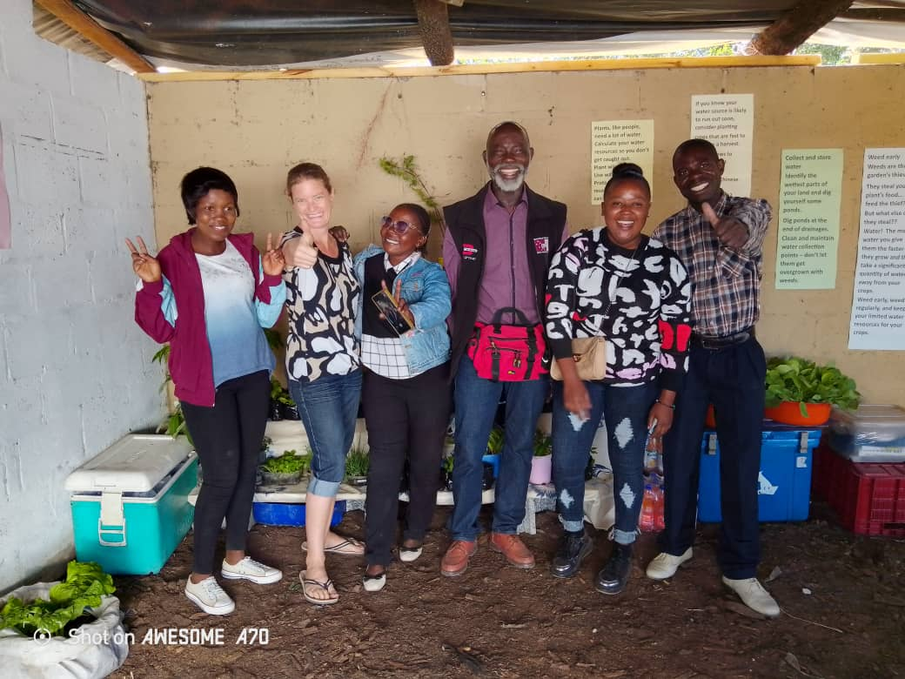In a severe drought where electrical loadshedding has been 12-21 hours per day for several months (reliant on hydro-electric), we have still managed to run and operate and do life without really feeling anything more than inconvenienced. We have not lost work time, income or other means of survival.

We are beyond blessed.